**Personal Portfolio for Release one**

In this release, my work part is search, login function and two php pages: gallery and eBooks. The PHP files I have uploaded to portfolio in GitHub are the page codes. The contents in the files were made by all group members and I have contributed my part of work. The reason why I choose those files is because those files contains most of my work.

The contents below are some examples of my work with a brief description.

**Sprint 1:**

In this sprint, my work is the search part and login part.

**Search**:

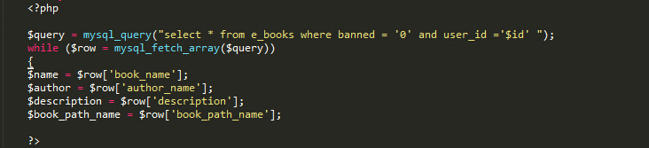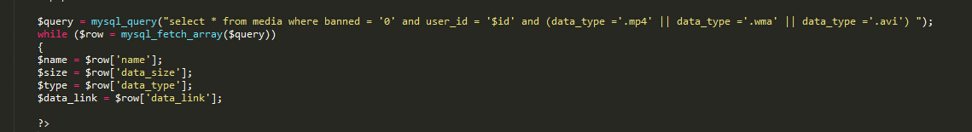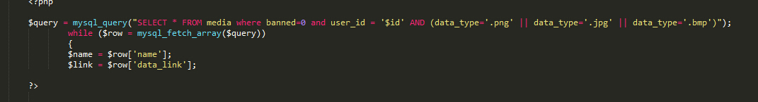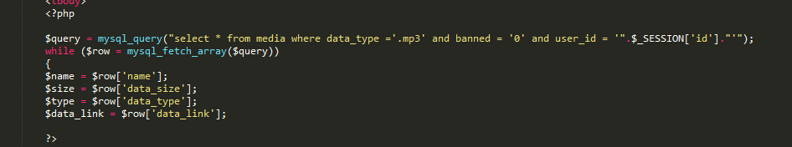

For current stage, the search function is almost same in different pages, the result of the codes above is to show the users the files they have uploaded depends on their account status.

**Login**:

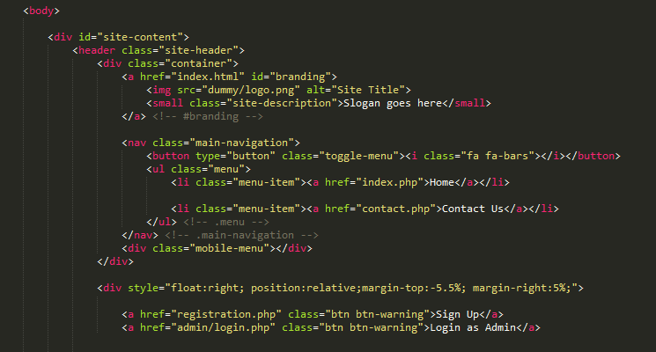

The codes above are the basic UI setting of this page. (Which not actually my job, but there are some slightly different than others.)

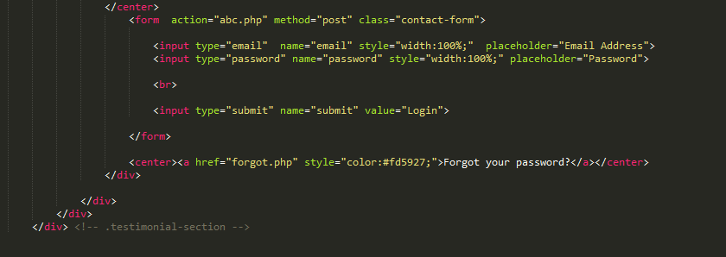

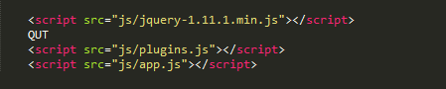

This part of code is about the login form. And for some of the functions used the jQuery as the plugins.

**Sprint 2:**

In this sprint, my work is focus on gallery and eBooks.

**Gallery:**

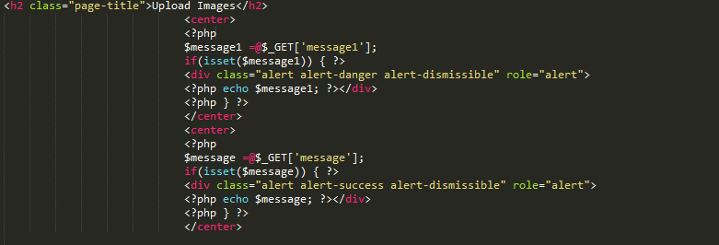

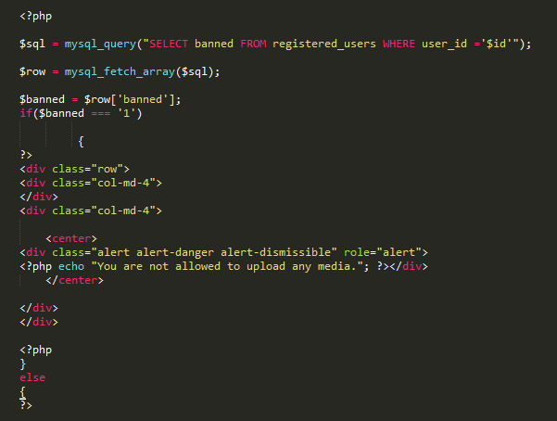

For the gallery page, the UI is same as others, and also have an account status check.

Users will upload/download/preview their photos from this page.

**EBooks:**

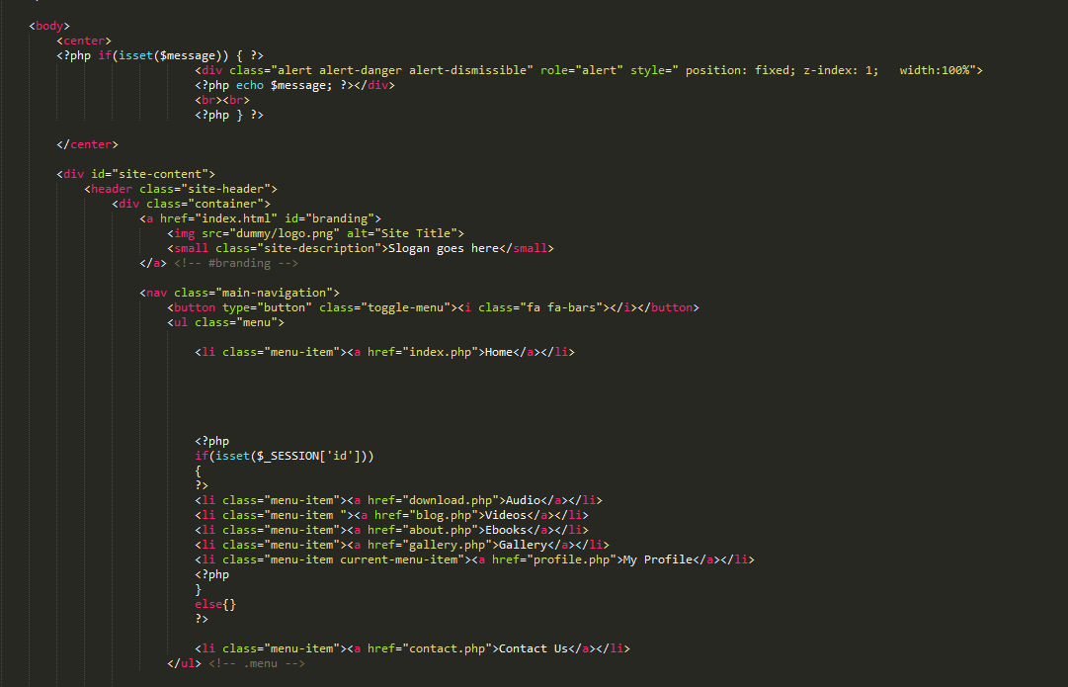

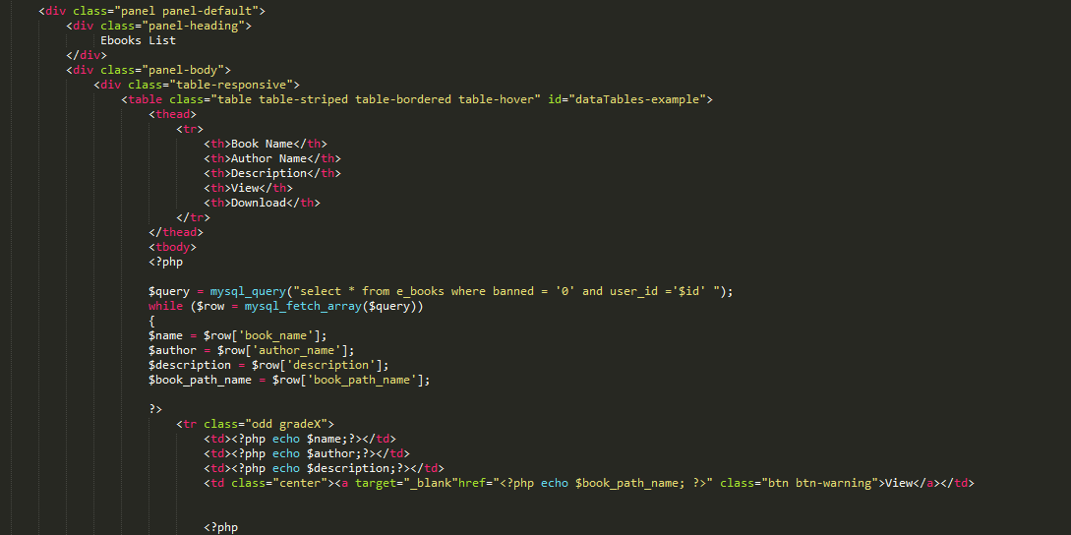

EBooks page is similar to the gallery page, but eBooks will contains more information about the books, such as Book name, author name, etc.

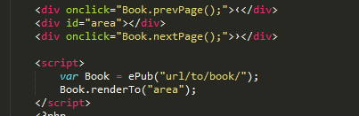

The EPUB reader may still has some problems, it would be solved later.